CREATE JAVA APPLICATION

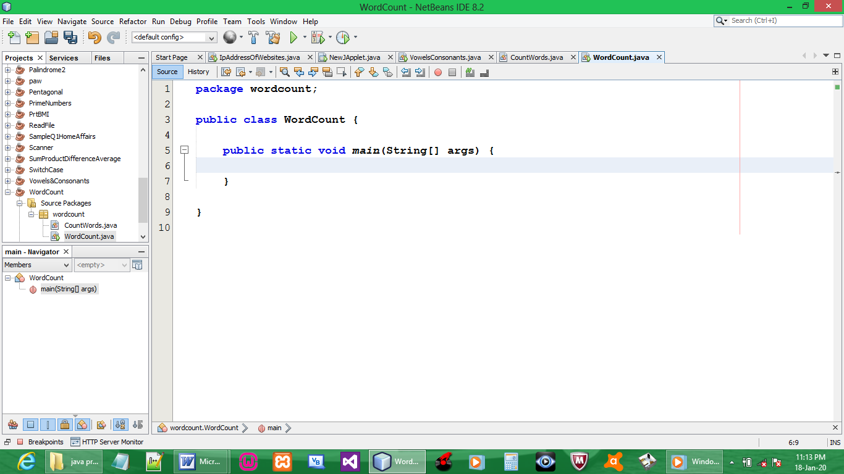

CREATE CLASS 2

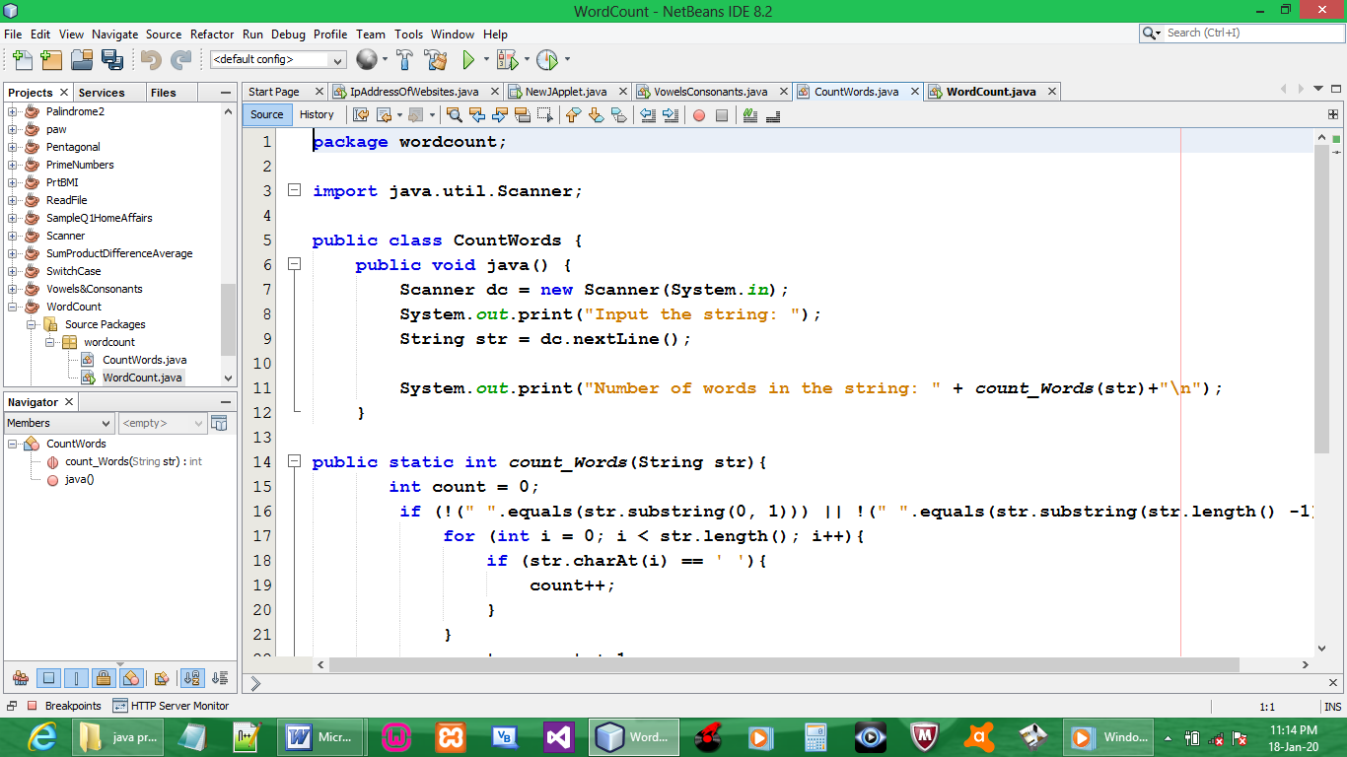

CODE class 2:

package wordcount;

import java.util.Scanner;

public class CountWords {
public void java() {
Scanner dc = new Scanner(System.in);
System.out.print("Input the string: ");
String str = dc.nextLine();

System.out.print("Number of words in the string: " + count_Words(str)+"\n");
}

public static int count_Words(String str){
int count = 0;
if (!(" ".equals(str.substring(0, 1))) || !(" ".equals(str.substring(str.length() -1)))){
for (int i = 0; i < str.length(); i++){
if (str.charAt(i) == ' '){
count++;
}
}
count = count + 1;
}
return count; // returns 0 if string starts or ends with space " ".
}
}

CODE class 1:

package wordcount;

public class WordCount {

public static void main(String[] args) {
CountWords jvObject = new CountWords();
jvObject.java();
}

}

OUTPUT:

